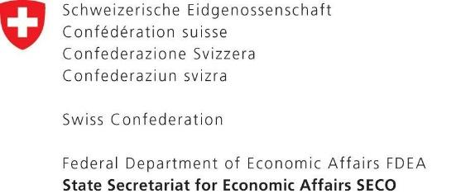

1. **Les entreprises à consulter**

|  |  |  |  |
| --- | --- | --- | --- |
|  | **Nom du bureau** | **Nom de l’expert** | **Email** |
| 1 | ENER | SOUAYED Monji | m.souayed@ener.com.tn |
| 2 | CAMI ENGINEERING | KHEMIRI ADBELHAK | cami@gnet.tn |
| 3 | ASSELEC |  | asse1008@gmail.com |
| 4 | Ingénieur conseil : DOUZI ABDELHAMID | DOUZI ABDELHAMID | douzi_abdehamid@yahoo.fr |
| 5 | BERI | TURKI MOUNIR | beri.sfax@tunet.tn |
| 6 | ELITE ENGINEERING COMPANY ( CETBI) | CHERIF HASSAN | cetbi@gnet.tn |
| 7 | RAYAL ELECTRIQUE | SAHNOUN LILIA | liliasahnoun3939@gmail.com |
| 8 | FLUENCO | ABDELHEDI OMAR | omar.abdelhedi@gmail.com |
| 9 | KESSENTINI MOHAMED | KESSENTINI MOHAMED | kessentini.mohamed@yahoo.fr |
| 10 | MORJENE SANA | MORJENE SANA | morgenesana@gmail.com |
| 11 | CRA2E | CHAMMEM MAROUEN | cra2e@yahoo.fr |
| 12 | HMIDETTE ZAHRA | HMIDETTE ZAHRA | zahrahmidette@gmail.com |
| 13 | BEN MEFTEH BADREDDINE | BEN MEFTEH BADREDDINE | badreddine.benmefteh@yahoo.fr |
| 14 | BEA INGENIERIE | JEMLI KHALED | beaingenierie@gmail.com |
| 15 | AT & C | AMEIMEA NEJI | kais.boudaya@action.com.tn |
| 16 | STE BATIMENT A BASSE CONSOMMATION (B.B.C) | MARRAKCHI AMAL | bbcetude2016@gmail.com |
| 17 | BOUKCHINA SEMI | BOUKCHINA SEMI | cfcsami@yahoo.fr |
| 18 | INFINITE ENERGY INTERNATIONAL | CHHOUD MOHAMED | contact@inf-energy.com |
| 19 | STEG ENERGIES RENOUVELABLES | HAMROUNI MONTASSAR BELLAH | steger@steg-er.com.tn |
| 20 | BEN MOHAMED LASSAD | BEN MOHAMED LASSAD | lassaadmed12@gmail.com |
| 21 | SCET-TUNISI | BEN ABDALLAH WALID | direction@scet-tunisie.com.tn |
| 22 | INNOV ENGINEERING | BEN JEMAA NIZAR | nizar@innov-engineering.com |
| 23 | AOUN ANIS | AOUN ANIS | aoun_anis@yahoo.fr |
| 24 | ALI IMED | ALI IMED | b2e.ing.imedali@gmail.com |
| 25 | BEN HMED ABIR | BEN HMED ABIR | benahmedabir@hotmail.fr |